**EXP : 8**

**Date : 10-02-2023**

**CREATE A SQL STORAGE SERVICE AND PERFORM A BASIC QUERY USING ANY PUBLIC CLOUD SERVICE PROVIDER (AZURE) TO**

**DEMONSTRATE DATABASE AS A SERVICE (DAAS)**

**AIM:**

To Create a SQL storage service and perform a basic query using any public cloud service provider (azure) to Demonstrate database as a service (Daas)

**PROCEDURE:**

1. Go to azure and go to sql database.

# Now create a sql databse

1. select the resource group and enter the server name that applicable.
2. In networking select allow azure services and resources to access this server.

# In additional settings select sample.

1. And the SQL database is deployed
2. Now go to query editor
3. Now again login to the SQL database

# Our tables will shown and type the query to excute.

# And our output is ready

**IMPLEMENTATION:**

**STEP1: GOTO AZURE AND GOTO SQLDATABASE.**

# STEP 02:- Now Create a Sql Databse

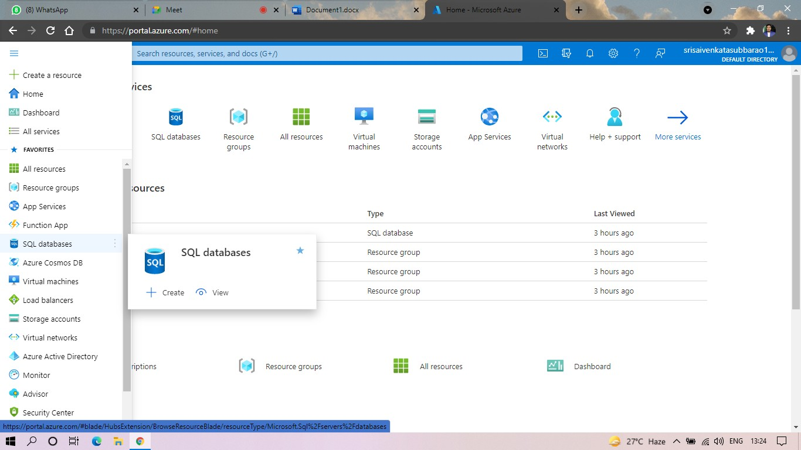

**STEP3: SELECT THE RESOURCE GROUP AND ENTER THE SERVERNAME THAT APPLICABLE.**

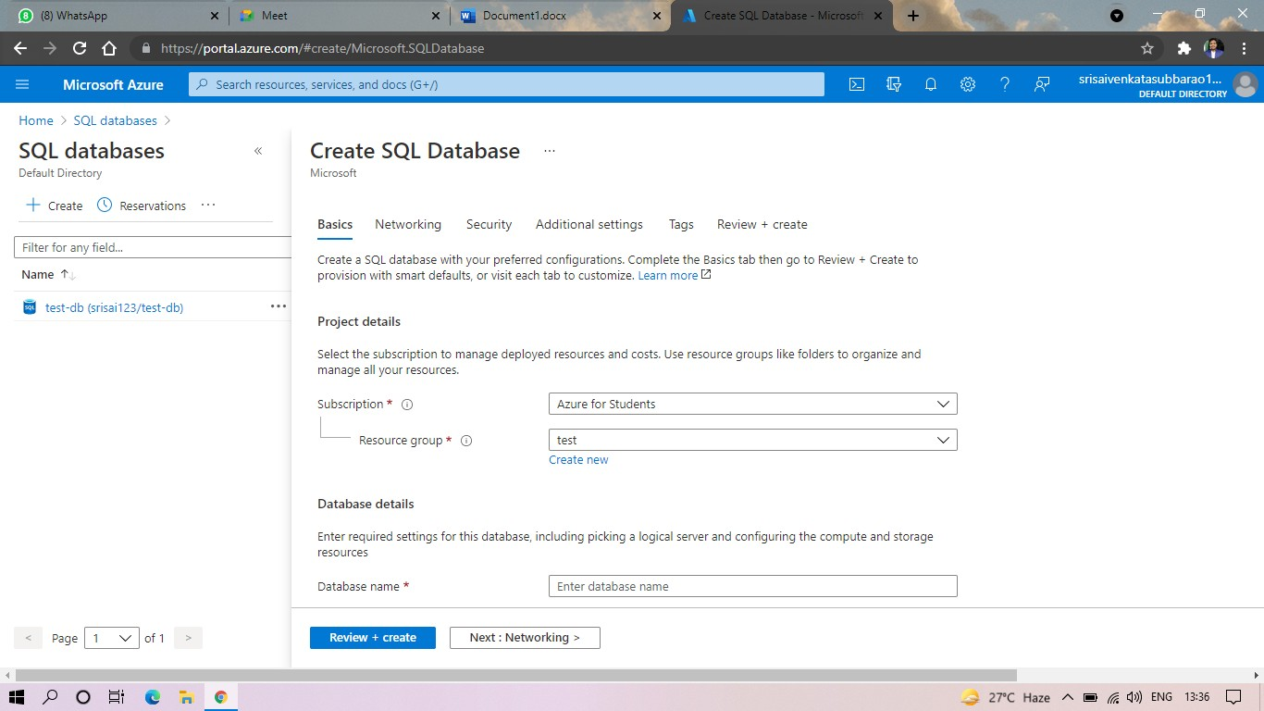

**STEP4: IN NETWORKING SELECT ALLOW AZURE SERVICES AND RESOURCES TO ACCESS THIS SERVER.**

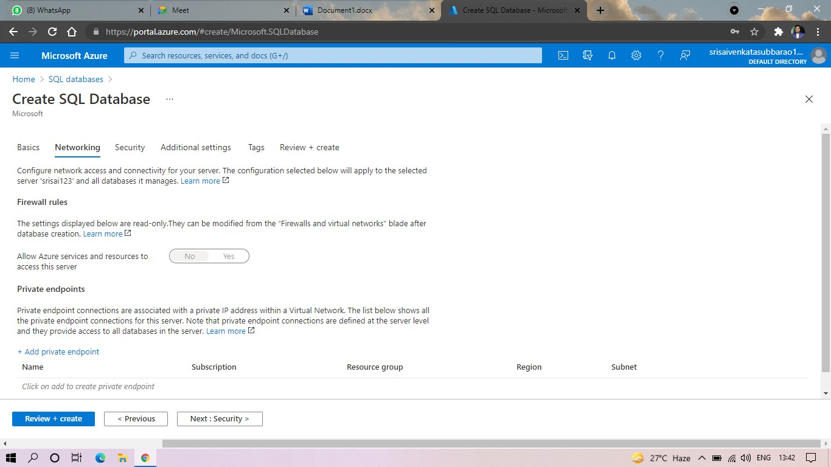

# STEP5: IN ADDITIONAL SETTINGS SELECT SAMPLE.

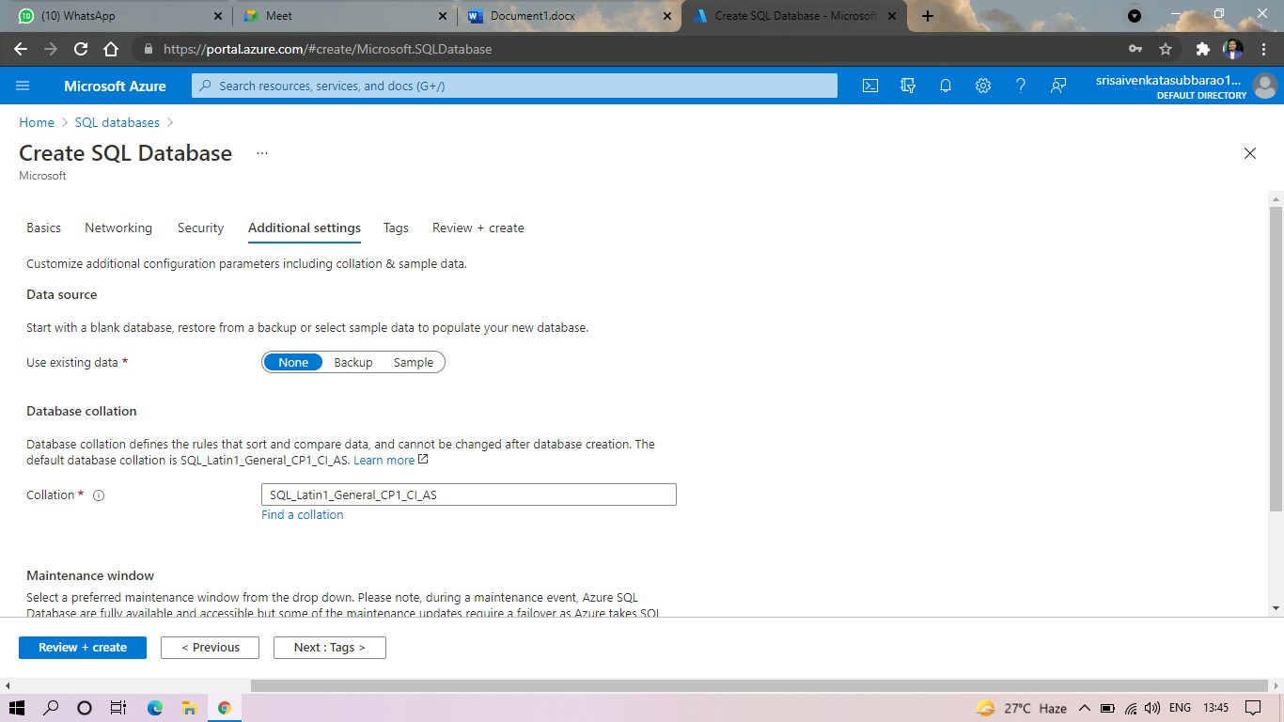

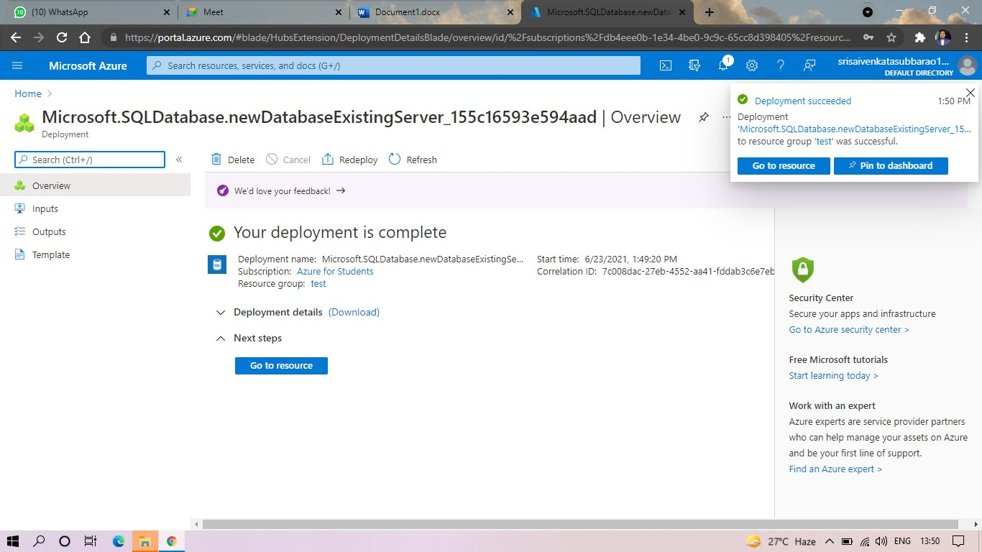**STEP6:AND THE SQL DATABASE IS DEPLOYED.**

# STEP7:AND NOW GOTO QUERY EDITOR.

**STEP8:AND NOW AGAIN LOGIN TO THE SQLDATADATABASE**

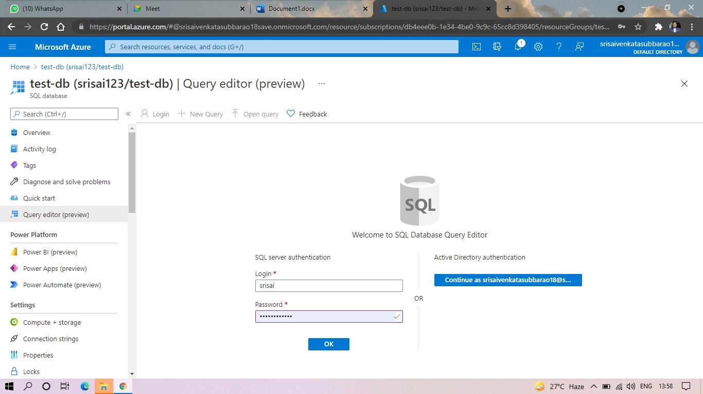

# STEP 9: AND OUR TABLES WILL SHOWN AND TYPE THE QUERY TO EXCUTED.

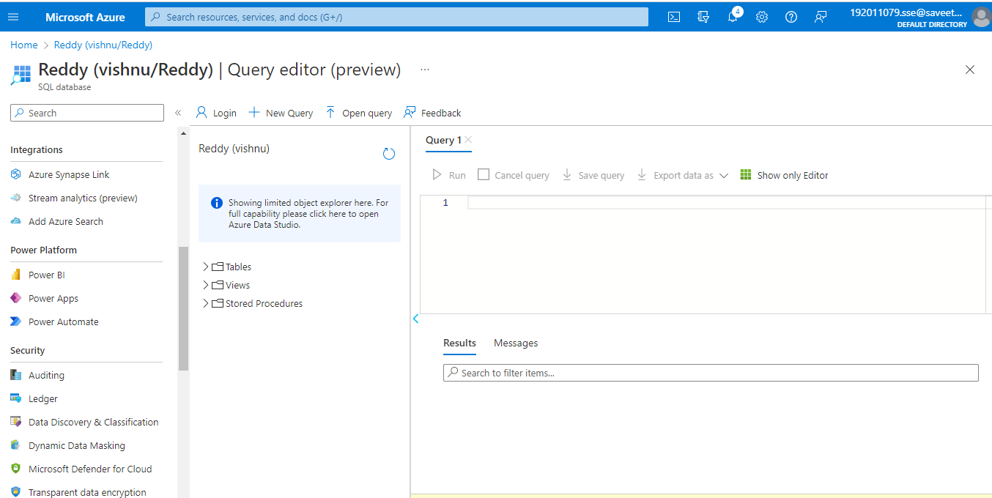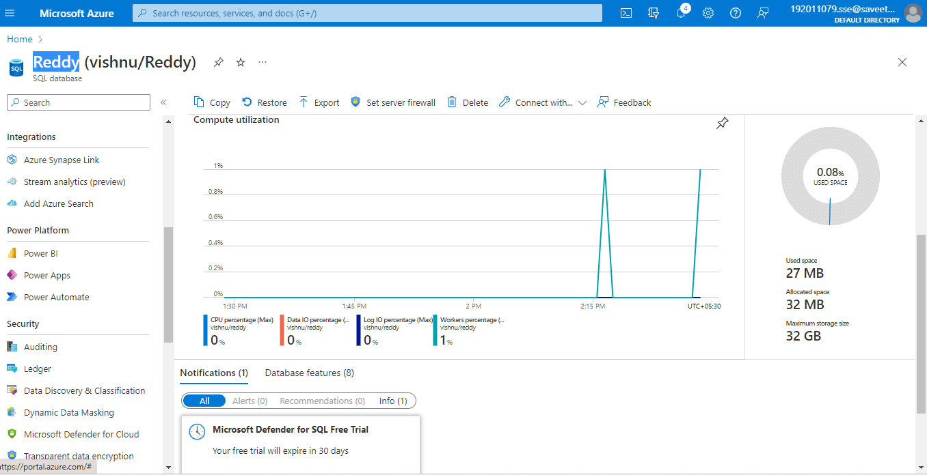

**STEP10: AND OUR OUTPUT IS READY.**

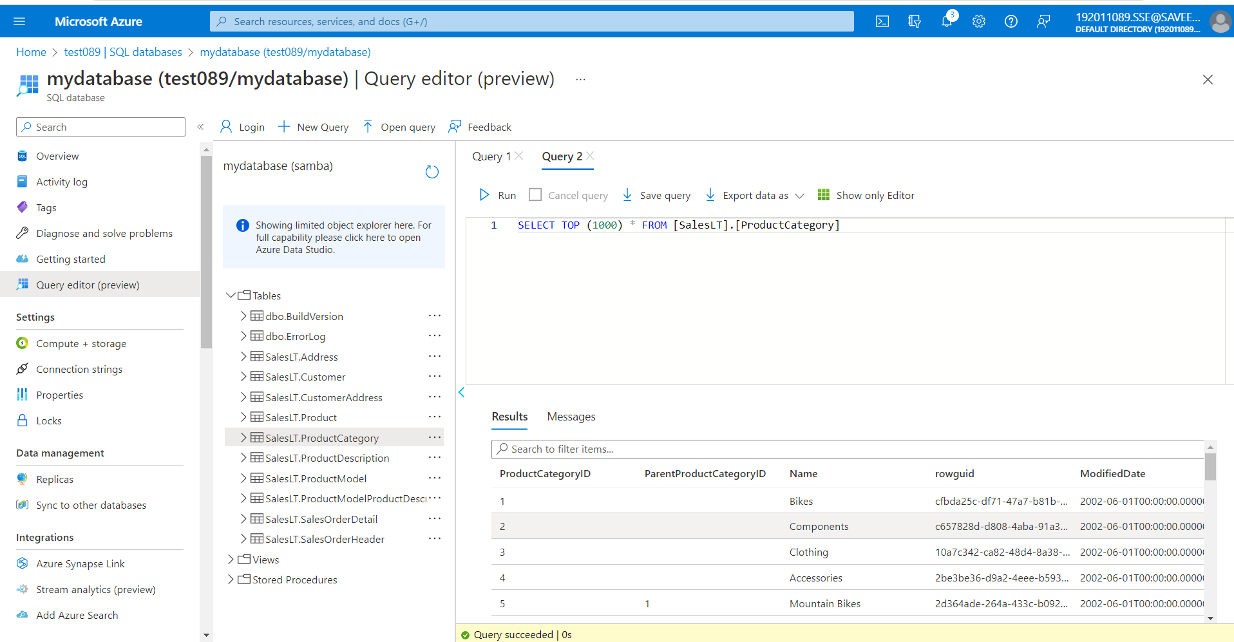

**RESULT:**

Hence SQL storage service and perform a basic query using any public cloud service provider (azure) to Demonstrate database as a service (Daas) is Created